# Gaussian Naïve Bayes Classifier in Sleep Stage Prediction Model

## Architecture

The Gaussian Naïve Bayes Classifier uses probability for doing its predicative analysis. With numeric values, the Gaussian Naïve Bayes Classifier classifies the numeric data into classes based on the following data/formulas :-

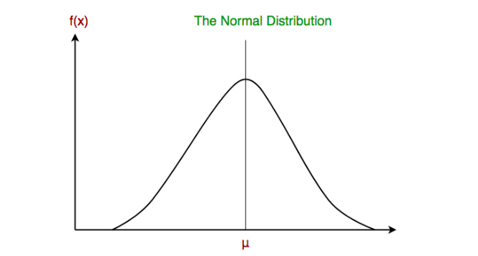



The default parameters offered by the Gaussian Naïve Bayes Classifier by scikit-learn of python are as follows :-

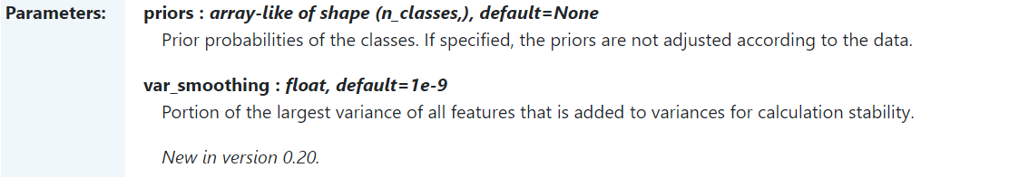

Since, not much variation is offered in the parameters, we stick with the default parameters in the Gaussian naïve bayes classifier.



## Classification Report

## 

## Github Repository

## <https://github.com/Jibitesh-Chakraborty2811/Sleep-Stage-Naive-Bayes-Classifier>

## 